Introduction
Welcome to your favorite AICT Lab. In this lab manual, we shall work together to learn and implement new computing concepts.

Skills to be learned:

- MS Office
- MS Excel– Data entry, formulas/functions, charts, pivot tables, data analysis & automation.

Week 4 | Do MS Excel Assignments  MS Excel Layout and Description | CLO3

Let's do some computing

Good Luck and Best Wishes !!
Happy Computing ahead :)

MS Office
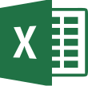
MS Excel
Professional
Documentations

Introduction to MS Excel
Microsoft Excel is a powerful electronic spreadsheet program you can use to automate accounting work, organize data, and perform a wide variety of tasks. Excel is designed to perform calculations, analyse information, and visualize data in a spreadsheet. Also this application includes database and charting features.
Starting Excel
Click on the Start button. And Click on All Programs. Select Microsoft Office from the menu options, then select MS Excel or you can search Excel in the search bar available on the desktop.
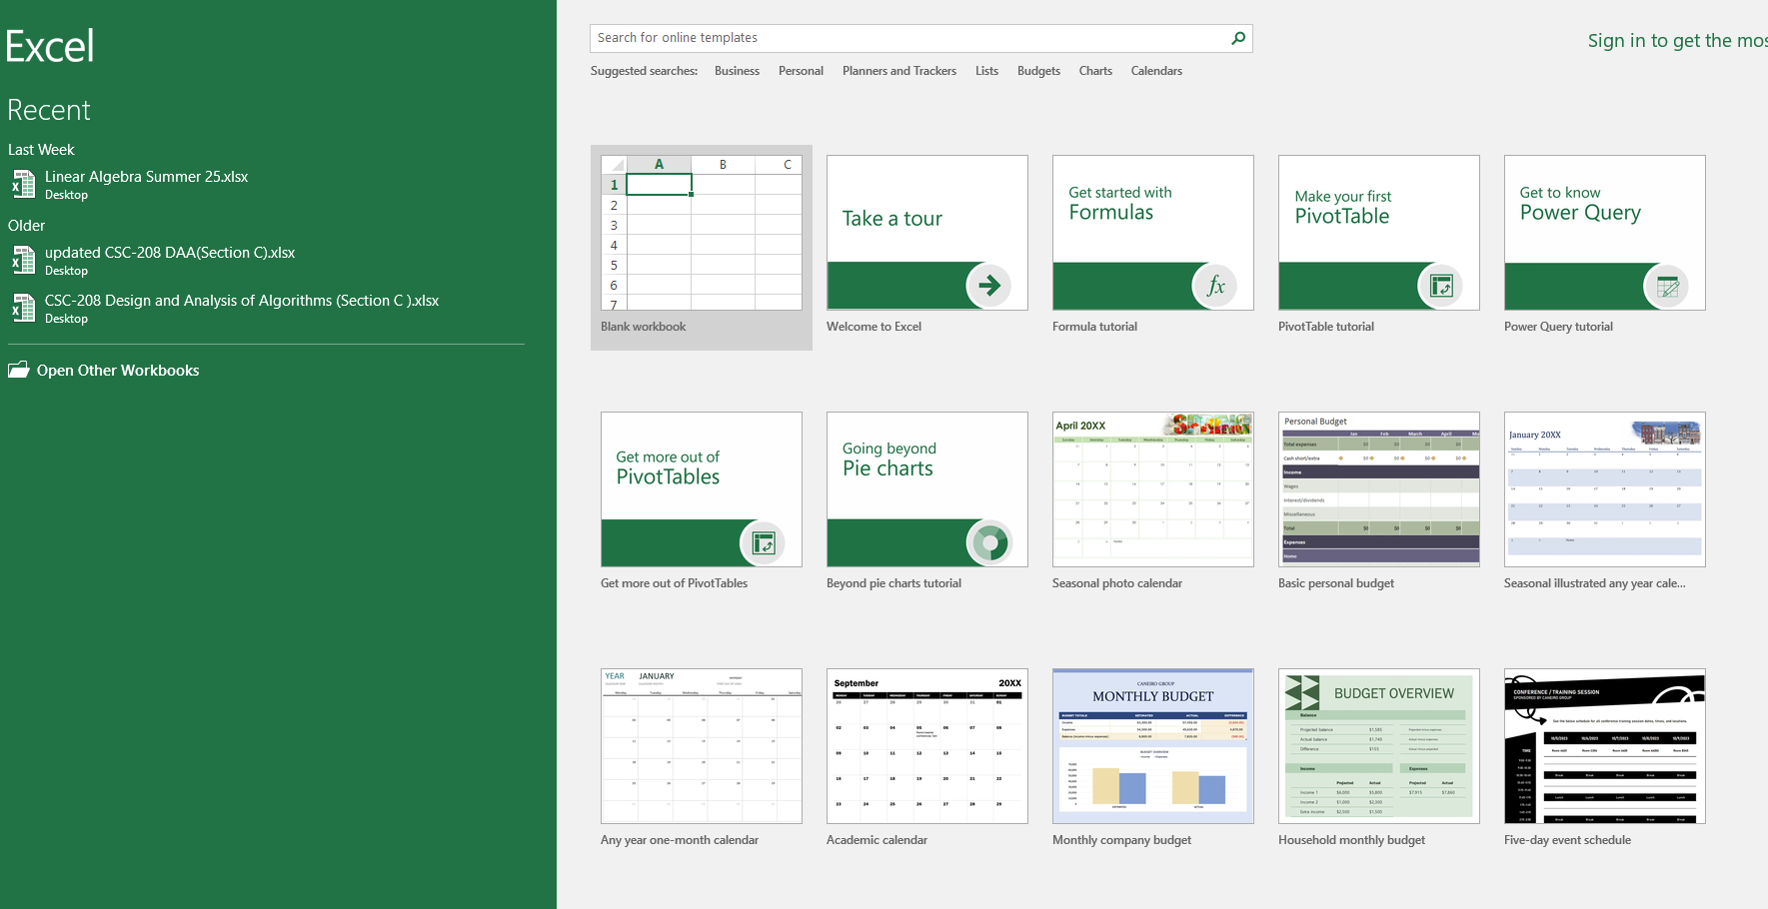
Figure 88-starting excel
Program window features

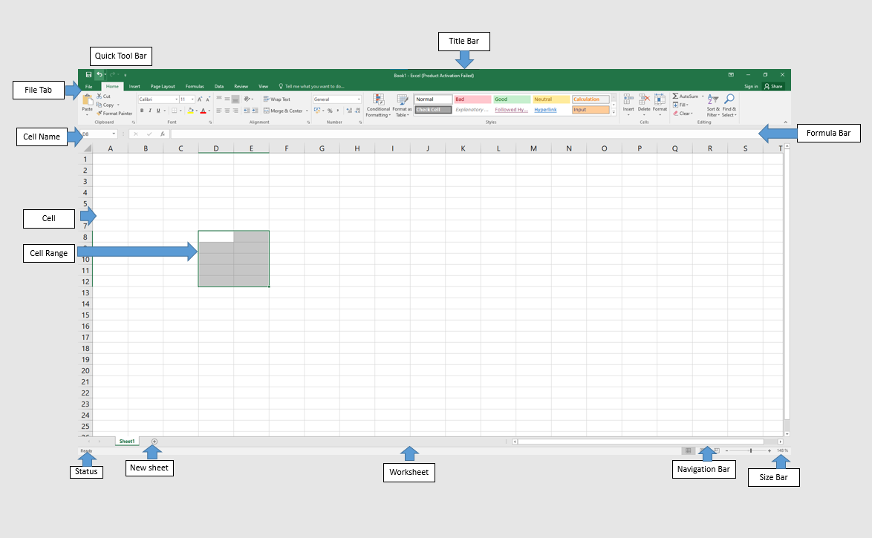
Figure 89-program window
Quick Access Toolbar: Displays quick access to commonly used commands.
Title Bar: Displays the name of the application file.
File Tab: The File tab has replaced the Office button. It helps you to manage the Microsoft application and provide access to its options such as Open, New, Save, As Print, etc.
Name Box: Displays the active cell location
Cell: The intersection of a row and column; cells are always named with the column letter followed by the row number (e.g. A1 and AB209); cells may contain text, numbers and formulas. 6
Range: One or more adjacent cells. A range is identified by its first and last cell address, separated by a colon. Example ranges are B5:B8, A1:B1 and A1:G240.
Status Bar: Displays information about the current worksheet.
New Sheet: Add a new sheet button
Ribbon: Displays groups of related commands within tabs. Each tab provides buttons for commands.
Formula Bar: Input formulas and perform calculations
Worksheet: A grid of cells that are more than 16,000 columns wide (A-Z, AA-AZ, BA-BZ…IV) and more than 1,000,000 rows long.
View Option: Display worksheet view mode.
Spreadsheet navigation

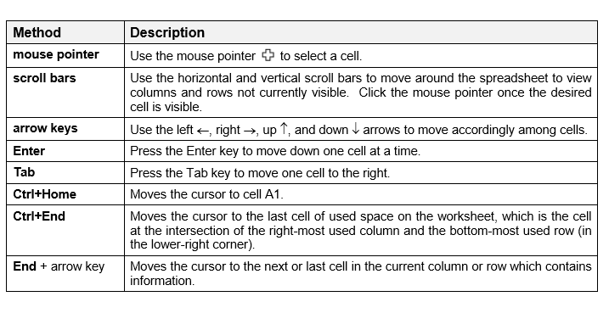
Figure 90-methods to navigate around a sheet

Creating formula
You can create any type of math calculation on your own using the following mathematical operators:
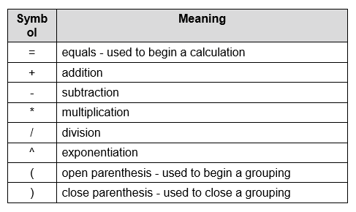
Figure 91-symbols used in formula
For example: =A1+A5 …...=B1+D1
Basic steps for creating a formula:
- Click in the empty cell which will contain the formula.
- Type an equal sign (=).
- Type the cell address or click the cell that contains the first number.
- Type the math operator (+ - / * ^).
- Type the cell address or click the cell that contains the second number. 6. Continue in this manner until the formula is complete.
- Use parenthesis for clarification.
- Press the Enter key
Important features of MS excel
Home tab: it has many important groups like font, alignment, numbers, cells group which has many important features like font size, font style, merge cells etc.
Insert tab: it has many important features like inserting pictures, tables, charts, header and footer.
Formulas tab: used to insert formulas in sheets. Its insert function and AutoSum features are mostly used.
Review tab: its spelling and thesaurus features are mostly used.
Inserting functions
This selection demonstrates how to use the Insert Function menu to create a formula. Click on the Insert Function button or from the AutoSum drop-down arrow and select More Functions to display a list of over 200 functions available in Excel. The Insert Function dialog box displays the function categories from the drop-down menu list. The function names will appear in the function name box below.
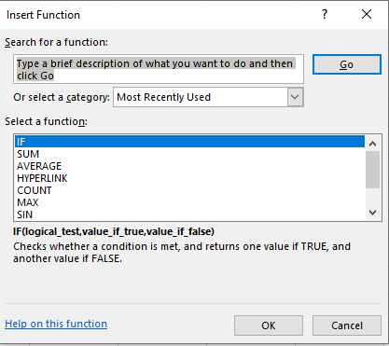
Figure 92-insert function dialog box
Once you select a category and a function name, click on the OK button. The Function Arguments palette will appear.
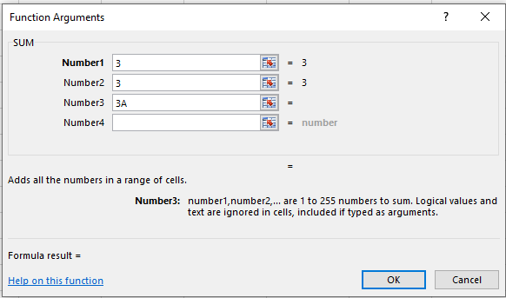
Figure 93-function arguments box
Type any numbers, cell addresses, ranges, or any other parameters in the required boxes, and then click on the OK button to insert the completed formula in the spreadsheet.
AutoSum:
Adding is the most common math operation performed in Excel. The Home ribbon includes an AutoSum button for adding. This button provides a shortcut to typing formulas.
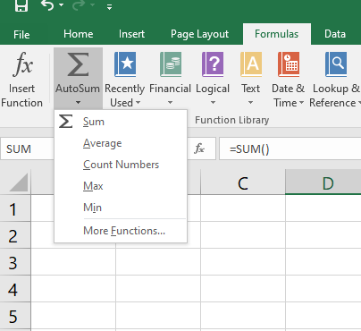
Figure 94-AutoSum button
Sum:
Adding is the most common function performed in Excel. The SUM function adds values. Specify values, individual cell addresses and/or range addresses in the numberx variables.
syntax =SUM(number1,number2,...)
examples =SUM(A10:A25)
=SUM(B15:C20)
Average:
An average sums all values and divides by the total number of values. Specify values, individual cell addresses and/or range addresses in the numbers variables. You can simply select the range of cells and select average from AutoSum button
Syntax =AVERAGE (number1, number2…,)
Examples =AVERAGE (15, 255, 45)
=AVERAGE (B2:B18)
Maximum (MAX):
Maximum indicates the largest value in the designated list of numbers.
Syntax =MAX (number1, number2 ...)
Examples =MAX (A15:A35)
=MAX (D10:D200, D225:D325)
Minimum (MIN):
Minimum indicates the smallest value in the designated list of numbers.
Syntax =MIN (number1, number2...)
Examples =MIN (A15:A35)
=MIN (D10:D200, D225:D325)
Exiting Ms excel
You can exit excel by clicking the close button provided at the upper right corner on the title bar. Or click the file tab and select the close option.

CS-141L Introduction to computing
Create an academic record of a student.
Objectives
To learn the most basic use of excel. How to make a mark sheet and how to insert pictures in excel.
Processing steps
Opening blank workbook
- Start excel and open a blank workbook. To do this, select the new tab and click on blank workbook.
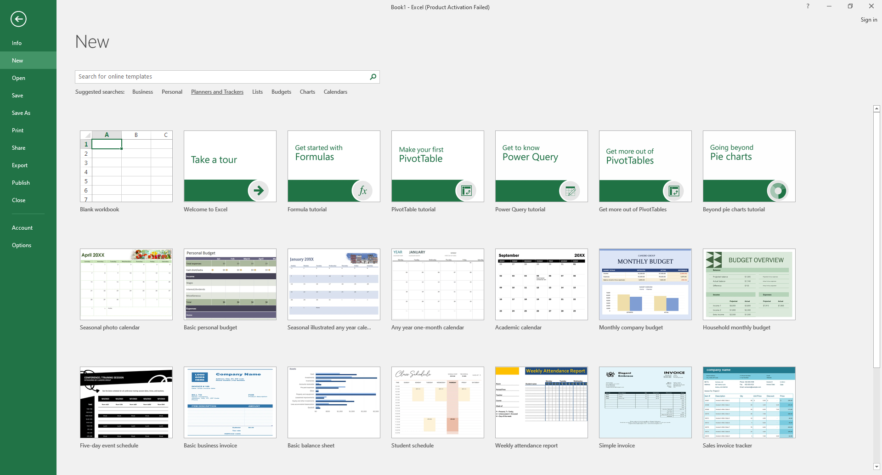
Figure 95-opening blank workbook
Inserting picture and shapes
- Start typing the given record in the workbook. In this case, I have given the heading at the top and then inserted a picture. To insert a picture, go to the insert tab and select insert picture button. The insert picture dialog box will appear.
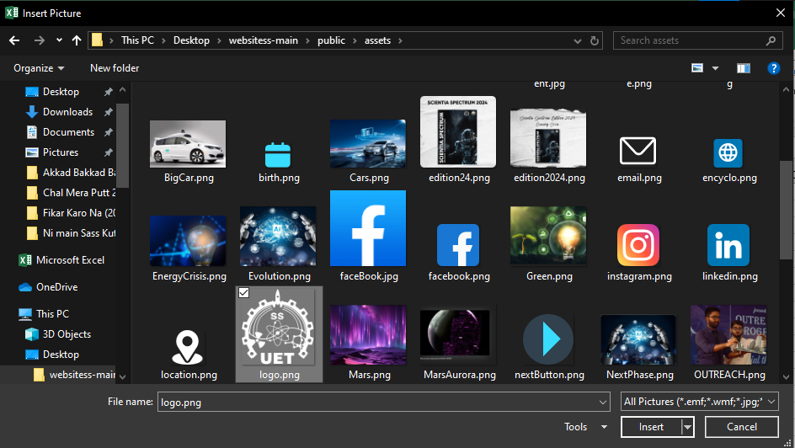
Figure 96-inert picture dialog box
- Select the desired picture and click on insert button at the bottom of the dialog box.
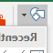
- Enter the given data in the workbook. To underline the text, I have used shapes. Go to the insert tab and click the down arrow to the right of shapes button.

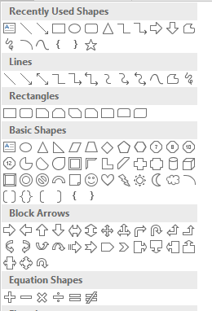
Figure 97-shapes
- Use the line shape to underline the text.
- To change the appearance of the text, go to Home tab and in the font group, font style and sizes etc. can be changed. And in the Alignment group, Merge & Centre is used to merge the text.

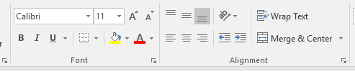
Figure 98-font and alignment group
Applying formulas
- To calculate the total of the values, place the cursor in the cell where you want to display total and go to the Formula tab and click the down arrow of AutoSum and select Sum.

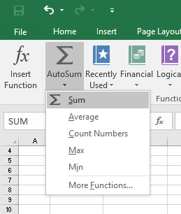
igure 99-calculating sum
- And select the values you want to total as follows:
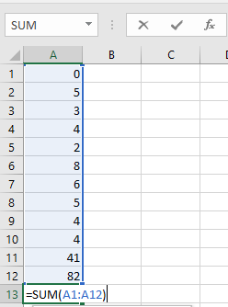
Figure 100-applying sum formula
- Similarly, calculate the average of all values. Go to the formulas tab and in the AutoSum button select average and then select the cell on which you want to apply the average formula. For example
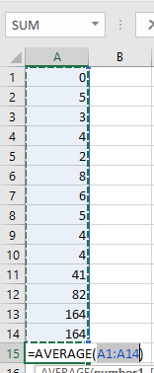
Figure 101-calculating average
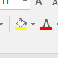
- To add colour shading to values, select the values and in the home tab in the font group select the desired colour from fill colour.

- To calculate the percentage, I have typed the following formula in the formula bar according to my data.

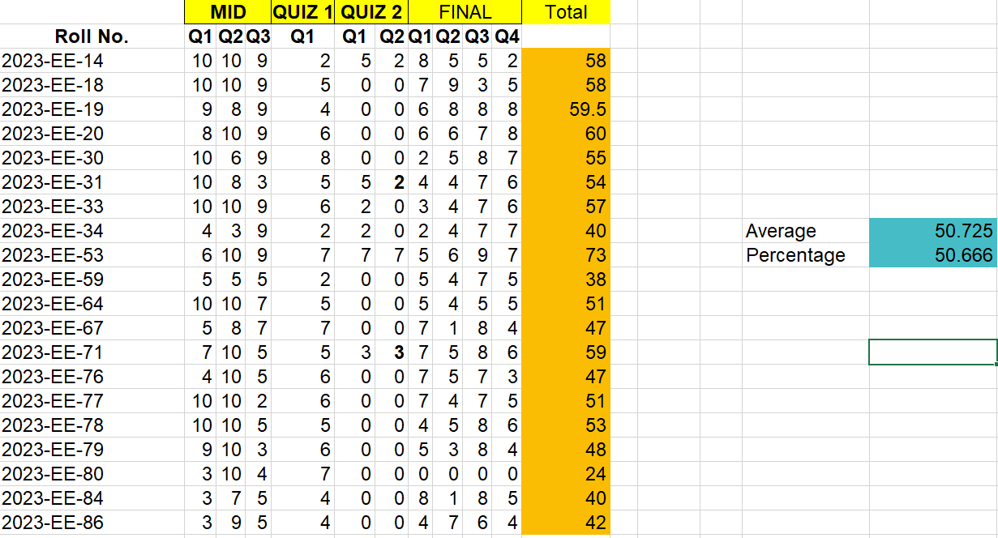
Figure 102-calculating percentage
Saving worksheet
- After calculations, you can save record. Go to the file tab and select saves as. Then select browse.
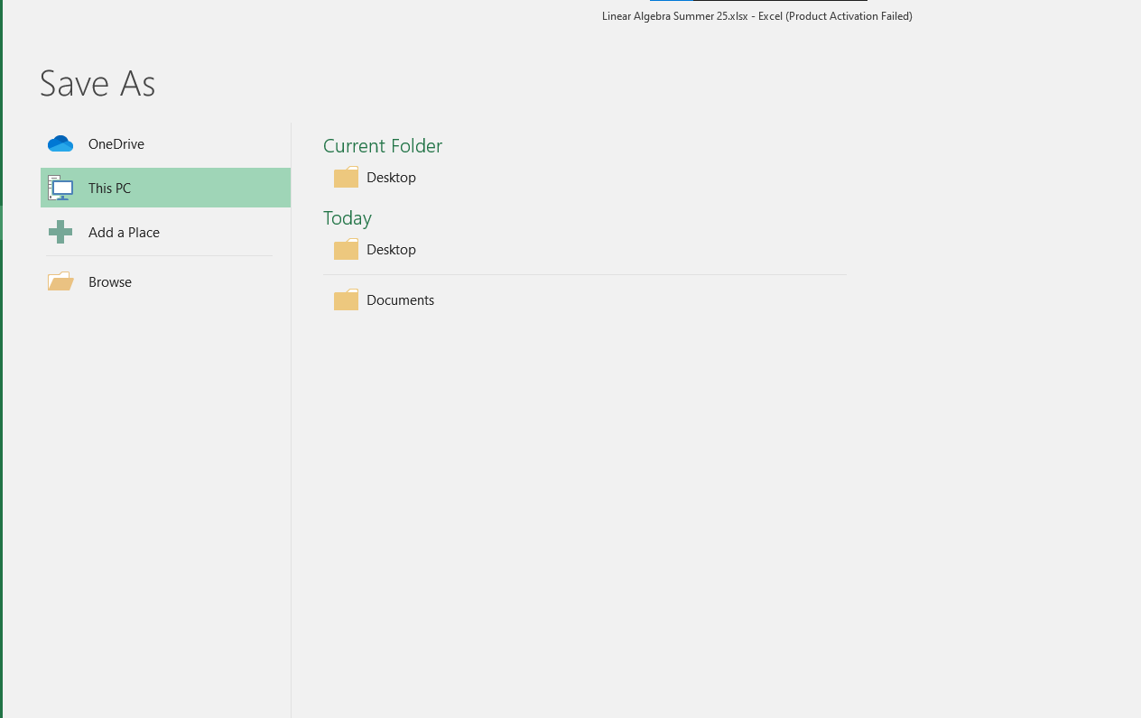
Figure 103-saving record
- Save as dialog box will appear. Enter the name of the file and location where you want to save the file. Then click the save button. The file will be saved.
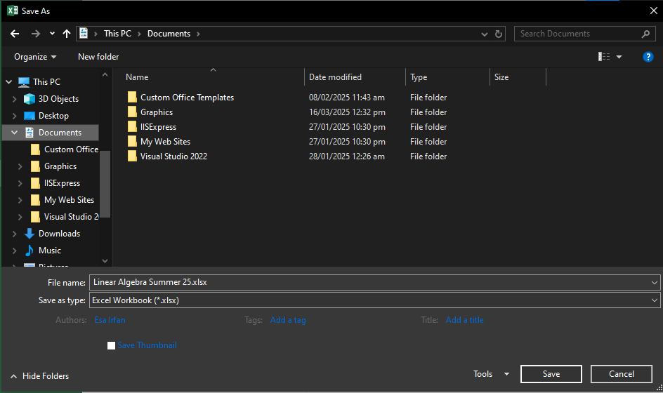
Figure 104-save as dialog box
Conclusion
After following the above steps, we can create, manipulate and save records in excel. We can also insert pictures in sheets and apply shading to them.

Sample
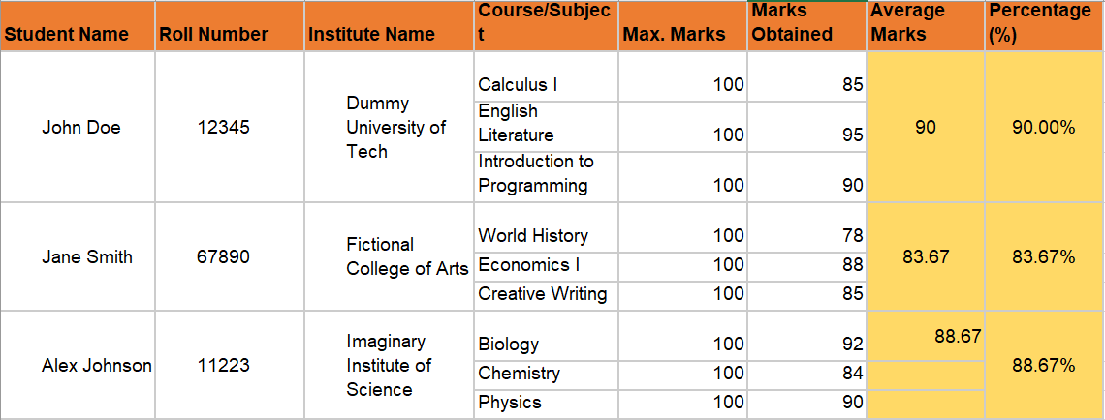
Figure 105: Sample document

